2020 Charter

THE HISTORY OF WHENUAPAI SCHOOL
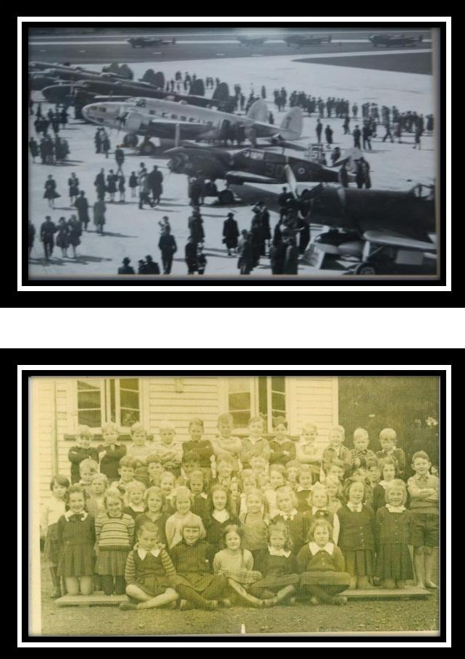

The story of Whenuapai Primary starts in 1957 when the Waitemata City Council decided to build a new school to be located on Kennedy Road in Kumeu. The property was just about to be acquired by the Council when it was decided the school should be situated in central Whenuapai near the Airbase. The Whenuapai Poultry Farm owned by the Andersons was sold to the Council and preparations for the school began. It started with just three permanent classes which are now rooms 12, 13 and 14.
The founding principal of the school was Mr McRae, whose wife was also on
the staff. They lived close by in the school house on the corner of Totara
Rd. But from small things big things grow, and 63 years on
Whenuapai School has grown and blossomed on those foundations laid in
1957. We are now entrusted with the education of approximately 444 children at the School and this number is predicted to grow significantly over the coming years. 2020 will mark the start of a period of change for the school. While many things will change, our commitment to positively impacting instruction remains our focus. We will do this by inspiring discovery and empowering learners through a cohesive, robust and modern curriculum.
The School continues to maintain very strong ties with the community and in particular the RNZAF and Anderson Family, both of whom have continued to be very strong and generous supporters of the School since inception. In fact, the School still is educating generations of the Anderson family to this day. The school is committed to serving its community

.
SCHOOL VISION AND VALUES
Our vision
“Our students will be actively involved in learning for life”

The School regularly discusses its vision. Students are at the centre of all our decision making and we strive to “inspire discovery and empower learning” in all we do.

Our Values
The School continuously reinforces at every touch point with parents, students or the wider community a set of values which create the foundation and building blocks for our vision. Those values were reviewed through 2017 and we believe the values are embedded in our school motto. In future these values will drive the thinking within the school.

Core Values:
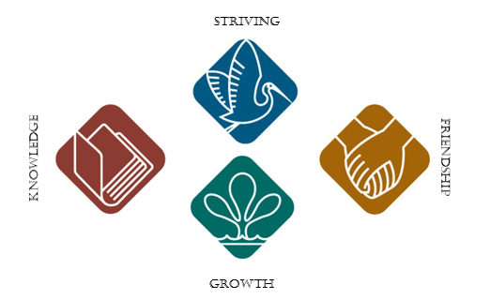
Striving
- Respect for Ourselves
- Respect Others
- Respect for the Environment
- Respect for Learning
Friendship
Knowledge

growth
The values align with the NZ Curriculum requirements.

Every child will progress towards reaching or exceeding curriculum level expectations regardless of their ethnicity, or education needs. This includes taking all reasonable steps to provide instruction in Tikanga Maori and Te Reo Maori for full time students whose parents ask for it. Significant work in the development of a curriculum model has enabled a cohesive, long term strategy in which continued improved outcomes for every student underpins all decision making.

WHENUAPAI SCHOOL STRATEGIC PLAN
2020 - 2022

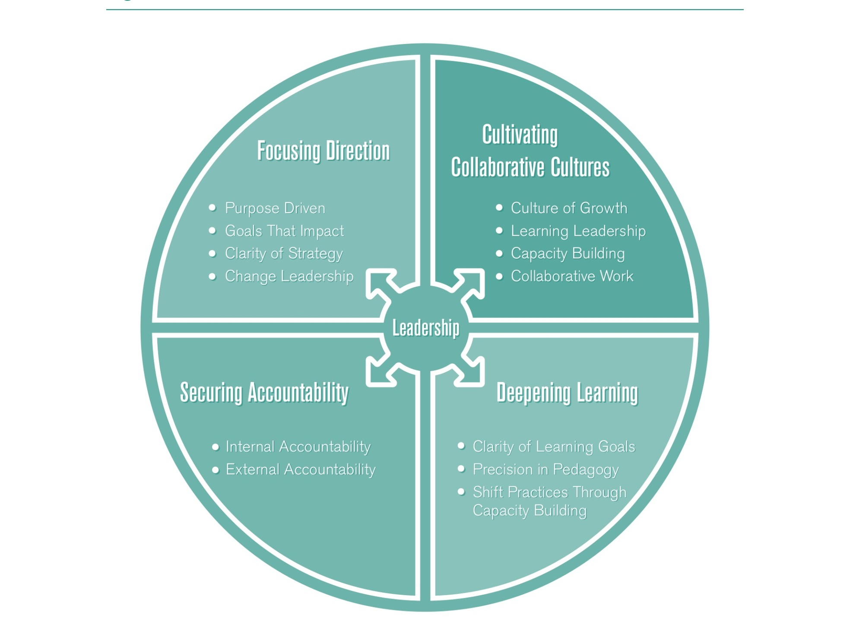
Created by Michael Fullan
Whāinga | Strategic Goal 1 | Strategic Goal 2 | Strategic Goal 3 | Strategic Goal 4
 | Build an inclusive school culture focused on wellbeing through collaborative professional learning and practice | Build social relationships by including all learners through authentic partnership with families and whānau | Build exceptional student achievement through high quality culturally responsive teaching and learning | Build our reputation and community confidence as the school of choice for a full primary education
Aim  Kaupapa-iti | By providing exemplary and inspiring opportunities, addressing individual learner strengths and needs, and fostering learner agency and wellbeing  - Leaders and teachers drive/model values behaviours/ actions that create a culturally responsive, well community of learners  - Provide quality teaching and learning, a safe environment and positive relationships, so students will achieve their highest potential  - Review and document systems and processes to identify sustainable and consistent inclusive practice schoolwide,  - Use review findings to ensure systems and processes are transparent, accessible and sustainable for students, staff and families  - Develop a schoolwide understanding of success at each year level with parent, family, whanau and learners | By developing educationally powerful two-way home school connections to lift student achievement, improve student outcomes and celebrate similarities and differences  - Formalise communications and engagement strategy and document across all school platforms - school handbook, teacher induction programme, website etc.  - Further strengthen formal systems and processes to improve the information flow between school and home  - Staff-wide PLD focusing on effective communication and engagement strategies, especially with our different cultural groups | By developing strong and informed leadership at both governance and management level, teachers are supported to be collegial, reflective, adaptive practitioners  - Whenuapai School fosters distributive leadership by providing ongoing leadership opportunities and pathways for students, teachers, parent, family and whanau  - Ongoing teacher development and student learning is transformed through learner agency, collaborative teacher efficacy, culturally responsive pedagogy, powerful learning and community connections  - Systematic tracking and monitoring of each student’s progress timely interventions occur to ensure students can identify next steps and achieve personal excellence  - Through the Learning Support Co-ordinator role grow teacher capability to support all learners | By consolidating an explicit, seamless, progressive learning pathway from Year 1-8  - Refresh the Whenuapai School vision to reflect our brand as a future-focussed learning environment  - Finalise the development of a curriculum map to include the things we value most to inform a localised curriculum  - Embrace digital technologies to support powerful connections with learners, family/whanau and community  - Maximise formal systems and processes to further improve the two-way flow of information (Teams to Leadership, Leadership to Teams)
Aim  Kaupapa-iti | By using the shared knowledge and strengths of our teachers underpinned by evidence-based practice students will achieve positive outcomes  - Ongoing teacher development and student learning is transformed through learner agency, collaborative teacher efficacy, culturally responsive pedagogy, powerful learning and community connections  - Implement Tier 2 (PB4L) and sustain Tier 1 through schoolwide integration of the programme principles and values and professional learning  - Embed and align the Kahui Ako Strategic Goals with our strategic direction | By developing strong mutually beneficial networks and relationships with key stakeholders such as COL, MOE and NZDF to support school, students, family and whanau  - Align all platforms of communication to support the development of the Whenuapai School brand we will strengthen our place in the community  - Embracing digital technologies to improve outcomes for students to ensure they are equipped to be agentic in their learning | By strengthening collaborative teacher efficacy to deliver a culturally responsive curriculum, through integrating new knowledge and understanding of student learning into professional practice  - Sustain learning from L&A and ALL(know your learner/ making connections to learner’s prior knowledge), to accelerate progress in Key Learning Areas:  - Embed in the appraisal systems, processes and teacher criteria, the principles underpinning Tapasa, Tataiako, Ka Hikitia to support accountability and responsibility for professional practice and student outcomes  - Embed an Impact Coaching model to support sustainability of ‘Best’ professional practice and accelerated progress for all learners | By developing a community of practice supported by individual and team self-review to optimise impact on student learning and progress  - Through our active partnership with the Kahui Ako build confidence and our credibility as an effective provider of middle years learning  - In-school leaders will engage in ongoing inquiries to both define success and inform our graduate profile and teacher development  - In-school COL leaders continue to develop and strengthen teachers’inquiries  - Ongoing teacher development and student learning is transformed through learner agency, collaborative teacher efficacy, culturally responsive pedagogy, powerful learning and community connections  - Review, strengthen current appraisal system and adapt to support accountability and responsibility for professional practice and growth
Aim  Kaupapa-iti | By increasing our capacity to be culturally responsive through collecting community and student voice and embedding into all aspects of school life  - Leaders and teachers to strengthen culturally responsive pedagogy and cultural awareness to enable all to have a strong sense of belonging and inclusion.  - Embed in the appraisal systems, processes and teacher criteria, the principles underpinning Tapasa, Tataiako, Ka Hikitia to grow our culturally sustainable practise | By developing authentic connections with whanau our students especially Maori and Pasifika will enjoy educational success in line with their identity, language and culture  - Consult and co-design with parent, family/whanau a two-year, localised curriculum  - Actively promote the Whenuapai Middle Years concept using a variety of media | By establishing systematic transition processes and practices for both the internal and external transition of students  - Review and strengthen processes for transitioning students into school, within school and from school both within and out of the Kahui Ako  - Strengthen/formalise the processes for sharing of information of new students schoolwide | By providing our senior students with more opportunities to forge their own paths to follow their passions and strengths  - Develop annually a Year 7/8 information package which would include a prospectus, tailored information sessions and be responsive to parent, family, whanau and student voice  - Holistic approach to developing a strong learner agency in the middle years  - Maximise the engagement with the Kahui Ako Year 7/8 network to strengthen our capability

2020 Annual Plan

Whāinga - Strategic Goal 1 - Build an inclusive school culture focused on wellbeing through collaborative professional learning and practice
Aim / Kaupapa-iti​ - ​By providing exemplary and inspiring opportunities, addressing individual learner strengths and needs, and fostering learner agency and wellbeing
 | Activity/Output | Who | When | Resource | Indicators / Measures of Success | Progress to Date
Leaders and teachers drive/model values behaviours/ actions that create a culturally responsive, well, community of learners  Provide quality teaching and learning, a safe environment and positive relationships, so students will achieve their highest potential  Review and document systems and processes to identify sustainable and consistent inclusive practice schoolwide,  Use review findings to ensure systems and processes are transparent, accessible and sustainable for students, staff and families  Develop a schoolwide understanding of success at each year level with parent, family, whᾱnau and learners | Create a Whenuapai model of CRP | In school  COL leaders  DP with team | All year | Meeting time | Completed, ready to be reviewed for 2021
 | Develop and implement a plan to authentically honour and celebrate  our cultural diversity within class, team and across school | Teams | Termly | Our community | Plan developed, implemented. Termly celebrations within contexts
 | Develop and implement an in depth Induction programme for our new teachers that sets them up for success | DP/Principal | Beginning of the year | Meeting time:  Learning  Network | Developed and implemented:  Teacher feedback positive
 | Develop and implement a process to support the provisionally registered teachers programme for both the PCTs and Mentor teachers | Senior leadership team |  |  | Developed and implemented:  PCT feedback positive
 | Create an appraisal document to ensure quality teaching and learning, positive relationships that are responsive to teaching and learning success. | Leadership team | All year | Arinui | Actioned, reviewed at both Team and  Leadership Meetings
 | Review and document systems and processes to identify sustainable and consistent wellbeing practice schoolwide (for all). | Leadership team | All year | MOE  documents Wellbeing survey | Evidence of systems implemented that support wellbeing
 | Review community feedback to ensure systems and processes are transparent, accessible and sustainable for students, staff and families | Principal / BOT | All year | Survey  Monkey  Focus  Groups | Positive feedback from whānau
 | Develop and implement a process for consultation to capture stakeholder voice about what ‘success’ feels like, looks like, sounds like for our learners | Principal  Senior leadership  Team | All year | Release time  Meeting time  Survey  Monkey | Process implemented to capture whānau voice
 | Review and implement change to strengthen the delivery of ESOL to  support teachers and learners | DP  Teachers  Teacher Aides | Term 1  Term 4 |  | Learners and teachers are well supported  Programme implemented
 | Identify Maths as a Key Learning area for all year levels | Maths team | All year | Curriculum budget PLD budget | Through PLD plan  Maths is a focus area
 | Identify Digital Technologies as a Key  area for all year levels | e-learning team | All year | MOE PLD | MOE PLD plan delivered  150 hours received for use over 18 months
Whāinga - Strategic Goal 1 - Build an inclusive school culture focused on wellbeing through collaborative professional learning and practice
Aim / Kaupapa-iti - By using the shared knowledge and strengths of our teachers underpinned by evidence-based practice students will achieve positive outcomes
 | Activity/Output | Who | When | Resource | Indicators / Measures of Success | Progress to Date
Ongoing teacher development and student learning is transformed through learner agency, collaborative teacher efficacy, culturally responsive pedagogy, powerful learning and community connections  Implement Tier 2 (PB4L) and sustain Tier 1 through schoolwide integration of the programme principles and values and professional learning  Embed and align the Kᾱhui Ako Strategic Goals with our strategic direction | Regularly meet to engage in professional learning through our teaching as inquiry model. | All teachers | All year | Meeting time  Inquiry time | Scheduled meeting time  Identified each term
 | Grow Middle Leader capability to implement an Impact Coaching model within their Teams and across the  Leadership Team | Team Leaders | All year | Professional learning | Professional learning completed  Middle leaders grow capability to lead teams evident through appraisal process
 | In-school COL leaders regularly feedback to staff about their learning from Kᾱhui Ako and outside professional development. | Karl Ganda  Carli Michelson | All year | Meeting time COL release time | Scheduled meeting time identified  Positive flow of new learning to impact on all teaching team
 | Further strengthen the fortnightly Hui to support the ongoing  development/implementation of PB4L | All staff | All year | Assembly time | Fortnightly ‘Hui’ is well placed to support  PB4L
 | Implement Tier 2 (PB4L) and sustain Tier 1 through schoolwide integration of the programme principles and values and professional learning | All staff | All year | Meeting time  PB4L  Conference  PLD budget | Implemented  Increase understanding through SET assessment evident
 | Embed and align the Kᾱhui Ako Strategic Goals with our strategic direction | Senior Leadership  Team | All year | COL Release time Senior leadership release time | Coherence  Alignment evident
 | An in-depth analysis of the 2019 Wellbeing data to identify key findings. | Leadership Team | Feb 2020 | Release | Completed  Findings acted upon
 | Continue to grow an understanding of success through our interactions with the Kāhui Ako | All staff | All year | Professional dialogue time | Definition of ‘success’ defined, embedded and shared
 | Further implement and strengthen play based learning in Years 1-3 | Year 1-3 teams Carli Michelson | All year | RRT time Reading  Recovery  Time | Growth in play based learning

Whāinga - Strategic Goal 1 - Build an inclusive school culture focused on wellbeing through collaborative professional learning and practice
Aim / Kaupapa-iti​ - ​By increasing our capacity to be culturally responsive through collecting community and student’s voice and embedding into all aspects of school life
 | Activity/Output | Who | When | Resource | Indicators / Measures of Success | Progress to Date
Leaders and teachers to strengthen culturally responsive pedagogy and cultural awareness to enable all to have a strong sense of belonging and inclusion.  Embed in the appraisal systems, processes and teacher criteria, the principles underpinning Tapasa, Tataiako, Ka Hikitia to grow our culturally sustainable practise | Leaders, teachers and support staff to gather student and whᾱnau voice to develop a Whenuapai CRP model. | Leadership Team  Teachers  Support staff | All year | Meeting Time | CRP Model  Designed, implemented and shared understanding evident
 | Establish an opt in Te –Wᾱnanga Study group to grow learning community  understanding of Te Ao Mᾱori | TBC | All year | Te-Wānanga resource | New study group formed
 | Create an appraisal system, that embeds processes, teacher criteria, the principles underpinning Tapasa, Tataiako, Ka Hikitia to grow our culturally sustainable practise. | Senior Leadership  Team  Team Leaders | Feb/March | Release  Meeting Time | New Document Designed and Implemented which supports personal growth

Whāinga - Strategic Goal 2 - Build social relationships by including all learners through an authentic partnership with families and whānau
Aim / Kaupapa-iti - By developing educationally powerful two-way home-school connections to lift student achievement, improve student outcomes and celebrate similarities and differences
 | Activity/Output | Who | When | Resource | Indicators / Measures of Success | Progress to Date
Formalise communications and engagement strategy and document across all school platforms - school handbook, teacher induction programme, website etc.  Further strengthen formal systems and processes to improve the information flow between school and home  Staff-wide PLD focusing on effective communication and engagement  strategies, especially with our culturally diverse parents, family, whᾱnau | Review, and if necessary improve, communications and engagement strategy and document across all school platforms - school handbook, teacher induction programme, website etc. | PA  Senior Leadership Team  Community Voice | All Year | Time | Clear processes and procedures evident
 | Audit formal systems and processes to improve the information flow between school and home | Leadership Team | All year | Meeting time | Clear processes and procedures evident
 | Staff-wide PLD focusing on effective communication and engagement  strategies, with our culturally diverse  Parent, Family, Whᾱnau | Senior Leadership  Team | All year | Professional  Learning  Meeting time | Increase in staff capability & commitment evident
 | Invite Whānau to a school Hui to  review journey and next steps | Principal | Term 2 | Public  Relation  Budget | Hui scheduled  Positive feedback
 | Identify Key Actions and implement in  2020 in response to feedback from  2019 Hui | Leadership Team | Term 1 | Meeting time | Action plan developed, implemented and monitored and shared
 | Complete a comprehensive review of all aspects of the reporting process with students, parent, family, whānau and teachers. Collate and implement findings | Deputy Principal  Team Leader  Teachers  Community Voice | Term 1 | Meeting  Time  Survey  Monkey | Reporting Processes meets whānau, teacher, learner need and supports student achievement.

Whāinga - Strategic Goal 2 - Build social relationships by including all learners through authentic partnership with families and whānau
Aim / Kaupapa-iti - By developing strong mutually beneficial networks and relationships with key stakeholders such as COL, MOE, NZDF to support schools, students, families and whanau
 | Activity/Output |  |  | Who | When | Resource | Indicators / Measures of Success | Progress to Date
Align all platforms of communication to support the development of the Whenuapai School brand in order to strengthen our place in the community  Embracing digital technologies to improve outcomes for students to ensure they are equipped to be agentic in their learning. |  | Complete an audit of all platforms of |  | Principal  Deputy Principal  PA | All year | Time | Completed  Alignment evident
 |  | communication to support the development of the Whenuapai School brand in order to strengthen our place in the community
 | Through a focus group process review the Parent Handbook to ensure it supports all Parents,  Families, Whānau |  |  | Principal  Deputy Principal  PA | Term 1 | Focus group meeting time | Focus group held  Feedback actioned  Parent Handbook available to whānau
 | Formally engage with the NZDF pastoral care team each term |  |  | Principal  LSC  Deputy Principal | Each Term | Meeting time | Excellent two way communication evident
 | Continue to foster and engage with COL schools to further strengthen our place in the wider community to maximise opportunities for all |  |  | Principal  Deputy Principal  COL Leaders | All year | COL  Release  Meeting time | Positive partnerships evident
 | Through our engagement with the external facilitator for Digital  Technologies implement the 2020 work plan to grow teacher capability |  |  | All teachers | All year | External  facilitator | Work plan delivered, majority of hours used  Sustainability plan developed for 2021
 | Through our engagement with the external facilitator develop a Year 1-8 pathway for the implementation of  Digital curriculum |  |  | e-learning team  Facilitator | All year | PLD  Allocation | Pathway developed and shared
 | Provide the appropriate resources to support the delivery of the Digital curriculum for Year 1-8 |  |  | Board | Term 1 | Budget allocation | Resourcing through 2020 budget evident

Whāinga - Strategic Goal 2 - Build social relationships by including all learners through authentic partnership with families and whānau
Aim / Kaupapa-iti - By developing authentic connections with whanau our students especially Maori and Pasifika will enjoy educational success in line with their identity, language and culture
 | Activity/Output | Who | When | Resource | Indicators / Measures of Success | Progress to Date
Consult and co-design with parent, family/whᾱnau a two-year, localised curriculum  Actively promote the Whenuapai Middle  Years concept using a variety of media  Continue to develop professional learning through the Tapasa and Ka Hikitia documents. | Develop and implement a process for consultation | Senior leadership team | Term 2 | Release time | Consultation completed  Localised curriculum developed and aligned with NZ curriculum
 | Continue to grow and develop our year 5-8 Kapa Haka group and provide this opportunity for years 1-4. | TBC | All year | Release time  Massey High  School  Students | Two Kapa Haka formed
 | Develop and implement a range of strategies to promote Year 7/8 | PA  Principal  Karl Ganda | All year | Release time | Increase in positive perception of our Year 7/8
 | Provide opportunities for a range of cultural groups. | Community  Staff | All year | Release time | Cultural groups formed and they perform throughout the year
 | Through the Kᾱhui Ako and in school expertise grow understanding of Tapasa and Kahikita documents | Deputy Principal  COL Leaders | All year | Meeting time | Increased understanding evident in discussion

Whāinga - Strategic Goal 3 - Build exceptional student achievement through high quality culturally responsive teaching and learning
Aim / Kaupapa-iti - By developing strong and informed leadership at both governance and management level, teachers are supported to be collegial, reflective, adaptive practitioners
 | Activity/Output |  |  |  | Who | When | Resource | Indicators / Measures of Success | Progress to Date
Whenuapai School fosters distributive leadership by providing ongoing leadership opportunities and pathways for students, teachers, parents, family and whānau  Ongoing teacher development and student learning is transformed through learner agency, collaborative teacher efficacy, culturally responsive pedagogy, powerful learning and community connections  Systematic tracking and monitoring of each student’s progress timely interventions occur to ensure students can identify next steps and achieve personal excellence | Provide ongoing PD opportunities that are aligned with differentiated goals |  |  |  | Principal, Deputy Principal, All teachers | All Year | PLD Budget | PLD plan developed
 | Foster leadership opportunities such as prefects and student leadership committees that impact on the school vertically |  |  |  | All staff | All year | Leadership opportunity  NYLD  Speakers | Leadership strategy implemented
 | Collecting community voice to inform where there is specific expertise |  |  |  | All teachers | Term 1 | Survey  Monkey | Survey findings shared and acted on
 |  | Review and develop reporting protocol |  |  | Senior leadership te  Whānau voice | Term 1/3 | Survey  Monkey  Google Doc | Reposting process reviewed, changes implemented
 |  | and process to ensure it is meaningful for the learner and their family
 |  | Review and strengthen tracking of |  |  | All staff | Term 1 - week 5  Term 2 - week 7  Term 3 -  Week 8 | NZEI TOD days | 3 TOD’s scheduled and implemented to support teacher data analysis
 |  | priority students at team and school level
 | Review and further develop the development of the IEP process to ensure it is collaborative and inclusive |  |  |  | LSC | Term 2 and  Term 4 | IEP Release | IEP Process documented
 | Review and strengthen the process of engaging with RTLB and the information sharing process |  |  |  | LSC | All year | Meeting time | Clarity evident
 | Continue to develop and strengthen Team leaders impact coaching capabilities. |  |  |  | Deputy Principal  COL Leader  External Facilitator | All year | PLD Budget | Impact coaching implemented with Team  Leaders - a growth in capability
 | Capture teacher voice re: leadership, opportunities, passions and skills |  |  |  | All staff | All year | Time | Job descriptions capture and honour additional delegations

 | Activity/Output | Who | When | Resource | Indicators / Measures of Success
 | Review, implement change to the delivery of ESOL to ensure it is responsive to learner need | Deputy Principal  Teacher Aides  Teachers | Term 1  Term 3 | ESOL  funding | ESOL programme implemented and strengthened
Through the Learning Support  Coordinator role grow teacher capability to support all learners and their whānau | Formalise and clarify Learning Support Coordinator role with all stakeholders | LSC  Principal | Term 1 | LSC Funding | Transparent processes and practices  Clarity around role for all stakeholders
 | Review, strengthen bullying response, tracking and management to mitigate incidences of bullying school wide | All staff | All year | MOE  Guidelines | Bullying incidents have been mitigated  Increase in Parents, Family and Whānau and student confidence in Whenuapai School approach

Whāinga - Strategic Goal 3 - Build exceptional student achievement through high quality culturally responsive teaching and learning
Aim / Kaupapa-iti - By strengthening collaborative teacher efficacy to deliver a culturally responsive curriculum, through integrating new knowledge and understanding of student learning into professional practice
 | Activity/Output | Who | When | Resource | Indicators / Measures of Success | Progress to Date
Sustain learning from L&A and ALL(know your learner/ making connections to learner’s prior knowledge), to accelerate progress in Key Learning Areas:  Embed in the appraisal systems, processes and teacher criteria, the principles underpinning Tapasa, Tataiako, Ka Hikitia to support accountability and responsibility for professional practice and student outcomes  Embed an Impact Coaching model to support sustainability of ‘best’ professional practice and accelerated progress for all learners | Continue to run the ALL programme through terms 2 and 3 school-wide? | All teachers | Term 2  Term 3 | Teaching time | Implemented
 | Standardise mentorship of BTs using Handbooks. | Deputy Principal | Term 1 |  | Beginner Teachers are well supported and successful
 | Document teacher development via  Arinui. | All teachers | All year | PLD budget | Arinui implemented
 | Schedule regular sharing of Teacher inquiries | All teachers | All year | Meeting time | Teacher inquiries shared regularly and celebrated

Whāinga - Strategic Goal 3 - Build exceptional student achievement through high quality culturally responsive teaching and learning
Aim / Kaupapa-iti - By establishing systematic transition processes and practices for both the internal and external transition of students
 | Activity/Output | Who | When | Resource | Indicators / Measures of Success | Progress to Date
Review and strengthen processes for transitioning students into school, within school and from school both within and out of the Kahui Ako  Strengthen/formalise the processes for sharing of information of new students schoolwide | Continue partnerships with local kindys and daycare centres for preschool - primary transition. | CM | All year | Release time | Ongoing relationship evident; Parents, Family and Whānau and children settled  Teachers have critical information
 | Review, strengthen inter-class transition processes to support all learners | Senior  Leadership LSC | Term 1  Term 4 | Release time | Inter-class transition process impacts positively on Learning Community to support all learners
 | Further develop and implement processes for inducting new children and their families into Whenuapai school | Principal  PA  Deputy Principal | Each Term |  | Scheduled meetings attended twice per term  Positive feedback, captured using Survey  Monkey

Whāinga - Strategic Goal 4 - Build our reputation and community confidence as the school of choice for a full primary education
Aim / Kaupapa-iti - By consolidating an explicit, seamless, progressive learning pathway from Year 1-8
 | Activity/Output |  |  | Who | When | Resource | Indicators / Measures of Success | Progress to Date
Refresh the Whenuapai School vision to reflect our brand as a future-focussed learning environment  Finalise the development of a curriculum map to include the things we value most to inform a localised and 21st century curriculum.  Embrace digital technologies to support powerful connections with learners, family/whᾱnau and community  Maximise formal systems and processes to further improve the two-way flow of information (Teams to Leadership, Leadership to Teams) | Finalise the development of a curriculum map to include the things we value most to inform a localised and 21st-century curriculum. |  |  | All teachers | Term 4 | PLD time | Curriculum map completed
 |  | Embrace digital technologies to support |  | All teachers | All year | Curriculum budget  Budget  MOE funded  PLD | Increase in home school partnership through the use of digital technology
 |  | powerful connections with learners, family/whᾱnau and community
 | Continue to use Seesaw school-wide and develop guidelines around how to best use this? |  |  | All teachers | All year | See-saw subscription | See-saw consistently implemented  100% engagement with whānau
 | Develop a 2 year curriculum map from years 1-8 |  |  | Leadership team | All year | Release  Term 4 | Developed
 | Develop and implement a responsive annual plan |  |  | Senior Leadership  Time  BOT | By end of  Feb |  | Developed, approved, implemented, monitored and reported on to Board of Trustees
 | Develop protocols to further improve the two-way flow of information (Teams to Leadership, Leadership to Teams) |  |  | Leadership Team  Office |  | Meeting time | Protocols implemented and monitored  Communication streamlined and issues mitigated
 | Work with external facilitator to develop teachers capabilities to implement the  digital curriculum |  |  | All teachers | All year | MOE PLD Plan  150 hours | Plan delivered, increase in teacher capability and confidence evident

Whāinga - Strategic Goal 4 -Build our reputation and community confidence as the school of choice for a full primary education
Aim / Kaupapa-iti - By developing a community of practice supported by individual and team self-review to optimise impact on student learning and progress
 | Activity/Output | Who | When | Resource | Indicators / Measures of Success | Progress to Date
Through our active partnership with the Kᾱhui Ako build confidence and our credibility as an effective provider of middle years learning  In-school leaders will engage in ongoing inquiries to both define success and inform our graduate profile and teacher development | Within-school leaders will engage in ongoing inquiries to both define success and inform our graduate profile and teacher development within School  Leaders | Karl Ganda  Carli Michelson | All year | Inquiry time  Through  COL Network | Graduate profile designed and shared
 | WSL to support teams to establish team inquiries based on their needs? | Karl Ganda  Carli Michelson | All year | Inquiry time  Through COL  Network | Team inquiries designed  Within school expertise shared
In-school COL leaders continue to develop and strengthen teachers’ inquiries | In-school COL leaders continue to develop and strengthen teachers inquiries | Karl Ganda  Carli Michelson | All year | Inquiry time  Through  COL | Team inquiries implemented, monitored and impact on teaching and learning shared
Ongoing teacher development and student learning is transformed through learner agency, collaborative teacher efficacy, culturally responsive pedagogy, powerful learning and community connections | Continue to unpack through  Professional Learning the Kᾱhui Ako drivers | Internal experience  Kᾱhui Ako expertise | All year | PLD Plan | All teachers are conversant with the drivers; evidenced in teaching and learning across the  Learning Community
Strengthen current appraisal system and adapt to support wellbeing, accountability and responsibility for professional practice and growth | Review, reposition and implement | Senior leadership team  External facilitator | Term 1 | PLD Team | Appraisal process supports wellbeing and professional growth

Whāinga - Strategic Goal 4 - Build our reputation and community confidence as the school of choice for a full primary education
Aim / Kaupapa-iti - By providing our senior students with more opportunities to forge their own paths to follow their passions and strengths
 | Activity/Output | Who | When | Resource | Indicators / Measures of Success | Progress to Date
Develop annually a Year 7/8 information package which would include a prospectus, tailored information sessions and be responsive to parent, family, whanau and student voice  Holistic approach to developing strong learner agencies and key competencies in the middle years  Maximise the engagement with the Kahui Ako Year 7/8 network to strengthen our capability and transitions | Develop a Year 7/8 information package including a prospectus, tailored information sessions and be responsive to parent, family, whanau and student’s voice. | PA  Year 7/8 Team | Term 2 | Release time | Information pack formalised
 | Include key competencies are in curriculum overviews and planning. | All teachers | All year | NZC documents | Evident in planning
 | Learner licence implemented through  5-6 and 7-8 | Year 5-8 team | All year |  | Evident in both teams; learners able to articulate
 | Track and monitor learner agency. | Year 1-8 | All year |  | Evidence of growth in Year 1-8 captured
 | Build student capability to peer and self-assess. | Leadership Team | All year |  | Evidence of growth in Year 1-8 captured
 | Establish a tracking system that monitors success in the key competencies and learner agency. |  | All year |  | Established
 | Engage with the Kᾱhui Ako Year 7/8 network to strengthen our capability and transitions |  | All year | Kahui Ako  Meeting  Time | Networking evident
 | Establish a tracking system that monitors success in academic success. |  | Term 1 | Meeting time | Implemented, effectiveness measured

